Social Media Campaign
#WeStandAgainstWorkplaceRacism
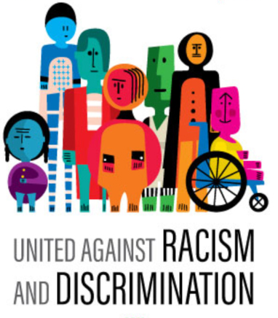
Let us all work together to create a workplace free of racism and discrimination, where everyone can exercise their human rights. We all can combat any form of racial discrimination and disrespectful attitudes.
Racial discrimination occurs when someone is treated unjustly or denied equal opportunities at the workplace because of their race, home country, ethnicity, or skin color.
The Racial Discrimination Act of 1975 (RDA) prohibits any form of racism in job postings, selection and recruitment procedures, training, transfers and promotion opportunities, and unfair dismissal. The RDA covers public and private sector personnel, full-time, part-time, and casual workers, contract staff, and commission agents, as well as trainees, interns, and those on probation.
Employers must implement policies and procedures that support equality. It might also include procedures for dealing with harassment and discrimination accusations from employees. Mistreating someone for submitting or attempting to file a racial discrimination lawsuit with the Human Rights Commission is illegal. Employers may face legal consequences if their employees participate in discrimination or harassment against colleagues at the workplace. Let us work together to create a world free of unfair treatment, where everyone may exercise their civil rights regardless of their racial background. Join us #FightRacism

